# A Day Fractured Forever, and Wnsuing Change: The Summer Uprisings of 2020 and Lessons Learned From the Front Lines

### Syrus Marcus Ware

It was summer — hot and dewy. Black Lives Matter had spent weeks planning the action after a successful action on Juneteenth of 2020. It was the middle of what we now lovingly refer to as the summer uprisings of 2020. People were becoming politicized and getting involved in actions and activisms around the world in the name of racial justice. In Tkaronto (the Mohawk name for Toronto, Ontario, Canada), we gathered 80 people — artists and activists on 16 June 2020 to paint a large-scale 7,200 square foot mural on College Street in downtown Tkaronto.

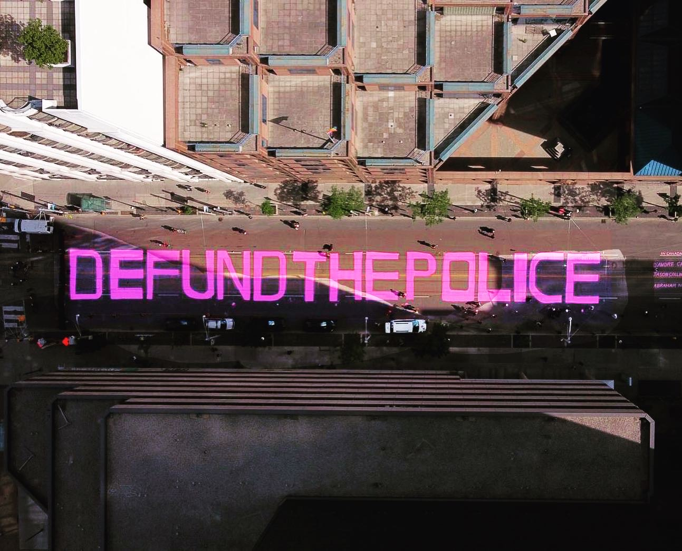

Figure 13.1: *DEFUND THE POLICE* street mural drone footage. Credit: Black Lives Matter Toronto (BLMTO).

Right in front of the Toronto Police Headquarters, the mural screamed ‘DEFUND THE POLICE’ in massive pink, queer letters. We had taken over the intersections of Bay and College Streets along with College and Yonge Streets and painted the large strip of letters between — along the block of College Street, using rollers and huge buckets of bright pink paint. As I stood there painting on that hot summer morning, I was worried; worried we would be attacked by the cops standing and watching our progress or that there would be charges laid. Instead, the action went off without a hitch. Thanks to some incredible 40-foot (12.2 m)-wide banners made by local artist and abolitionist Jenna Reid, we held the intersections for about an hour — allowing the paint to dry in the hot sun.

Our mural offering was the start of an action-packed day with marches and rallies in the name of Juneteenth[1]. It was documented with drone footage and photos and remained in situ untouched for several weeks following its creation. I even had an anonymous inquiry from a friend working at the city asking if the paint was water based. If so, they wanted to leave the mural. They had been trying to get the city to agree to paint a Black Lives Matter (BLM) mural after similar large-scale BLM-focused murals had been created in Washington and across the USA.

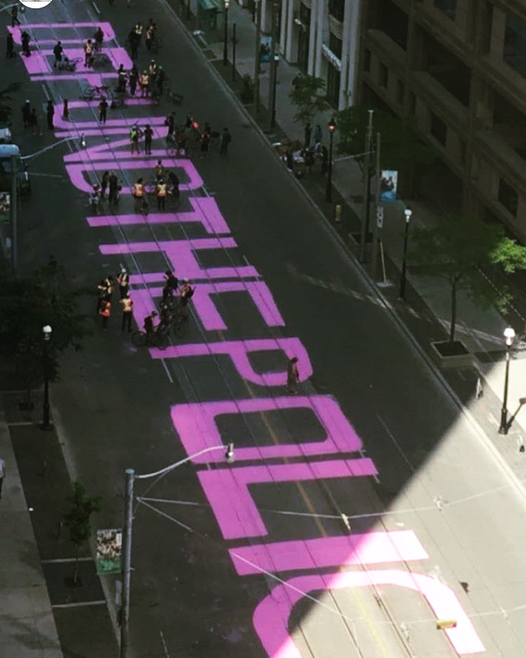

Figure 13.2: DEFUND THE POLICE street mural drone footage. Credit: BLMTO.

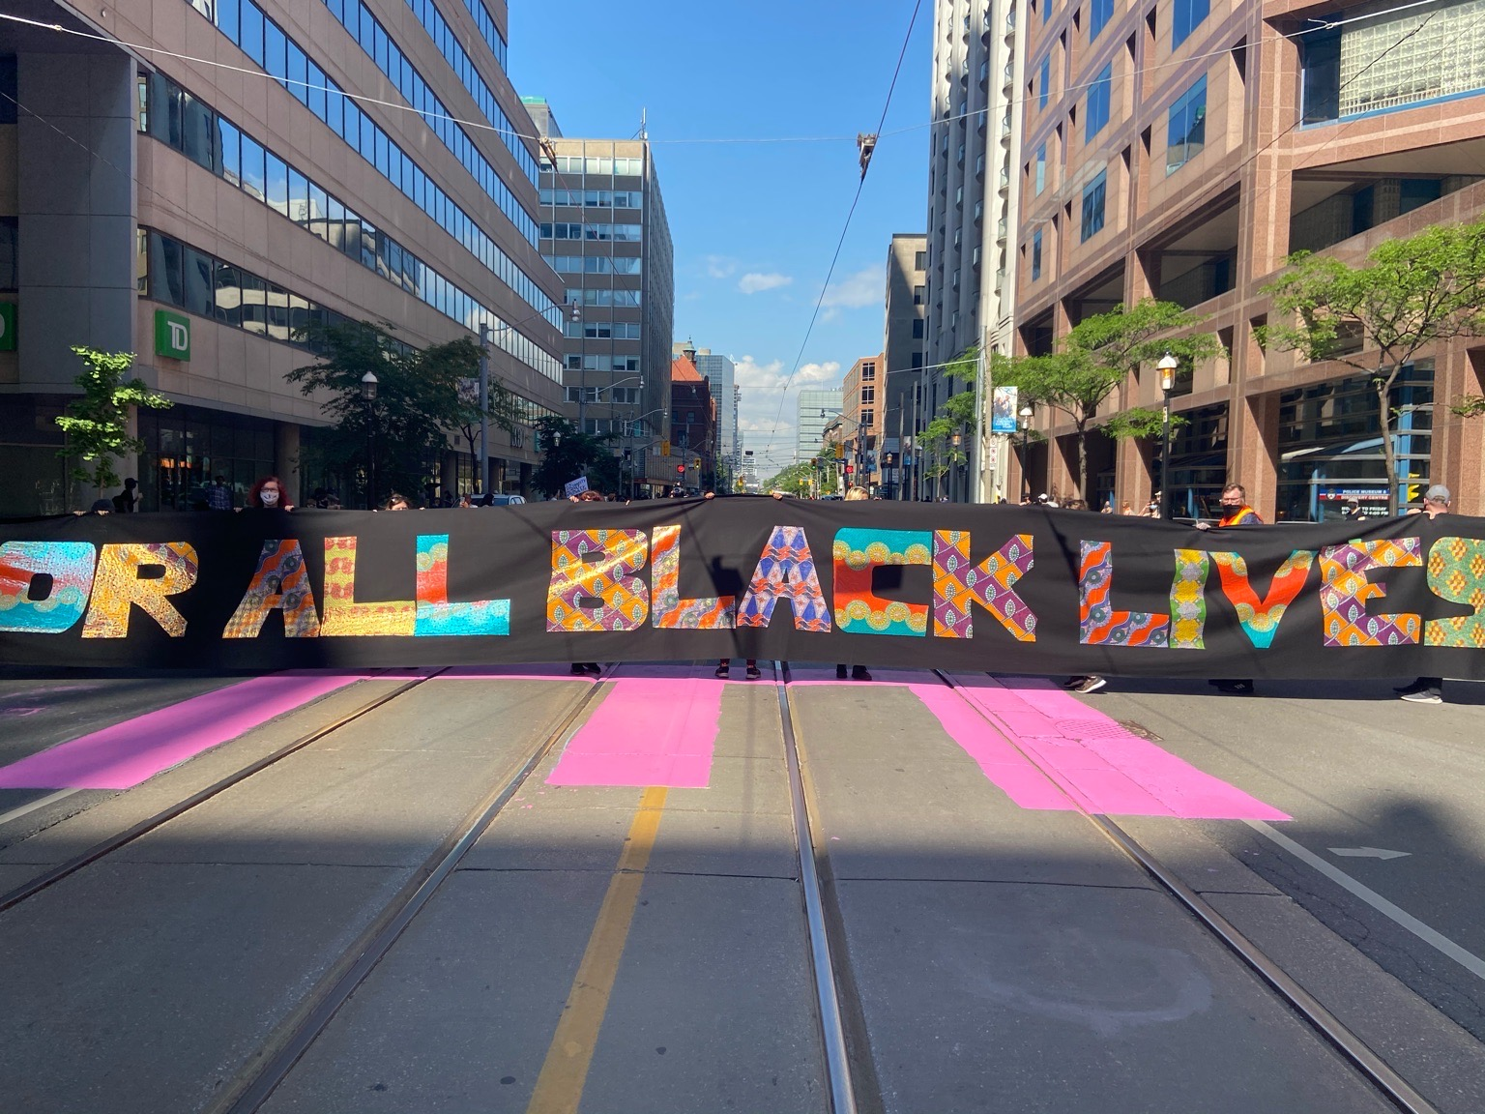

Figure 13.3: Banners and mural. Credit: Syrus Marcus Ware.

In the weeks following our mural creation, a sister mural was created by community members in Kensington Market — on August Street — proclaiming loudly and in bold colors that ‘Black Lives Matter’. In the public sphere, this message was being taken up by organizations all over Turtle Island (as referred to by many Indigenous communities in North America). On what came to be known as Black Out Tuesday, organizations and galleries blacked out their social media profiles and made solidarity statements about Black lives. Black artists and activists were charged with Instagram takeovers and demonstrative actions that made the organizations look good — even throwing some work towards Black folks often shut out of the arts and these organizations.

We entered July planning, thinking about how to address the monuments to slavery and colonialism spread across our city and province. The largest of these monuments was the policing and prison system, which grew directly out of slave labor camps and slavery. We met in parks to avoid surveillance and talked through possibilities. We decided to do an art project beautifying and addressing three monuments in the city:

* the statue of known racist, slaver, anti-Indigenous first prime minister of Canada, John A. McDonald;
* the statue of racist and architect of the residential school system in Canada Egerton Ryerson, whose system of violence resulted in thousands of deaths and millions displaced, and was exported and used to create the apartheid system in South Africa- affecting millions of Black people; and,
* the statue of King Edward IV, a colonial statue taken down in India during a decolonial process, but purchased through private interest and brought to Tkaronto and installed in Queens Park.

I am hesitant to discuss the actions in detail due to the safety of the activists in my community, but suffice to say Ryerson was beautified with pink paint. I have memories of the big splash of pink leaving the buckets, pausing in mid-air and landing on his racist face, dripping down his form. Thinking back to that morning of the paint splashing action, I remember being afraid and worried, because I did not know how it would go. I remembered that I felt similar painting the street and that we were fine to continue without disruption. However, this action did not turn out the same. Despite the few victories on that day, we had arrests and police violence.

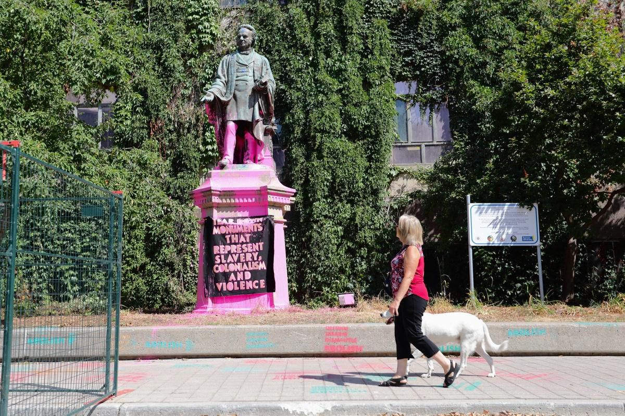

Figure 13.4: Ryerson ‘monument’ beautified. Photo credit: Syrus Marcus Ware.

The action started beautifully. My memories are like snippets; fragments fracture from a day of traumatic events. Colorful beautification with banners tied onto the base of the statues reading ‘TEAR DOWN MONUMENTS TO SLAVERY AND COLONIALISM’ in pink and neon green. Spray-painted stencils reading ‘abolish the police’ and ‘end white supremacy’ were scrawled on the sidewalks and across the statue’s base. There was a march behind a big pink banner — a swath of pink fabric body proclaiming our presence — from one site to the next. There was chanting and hope in our voices. I remember us arriving at John A. McDonald and a similar action happening; banners tied and paint landed.

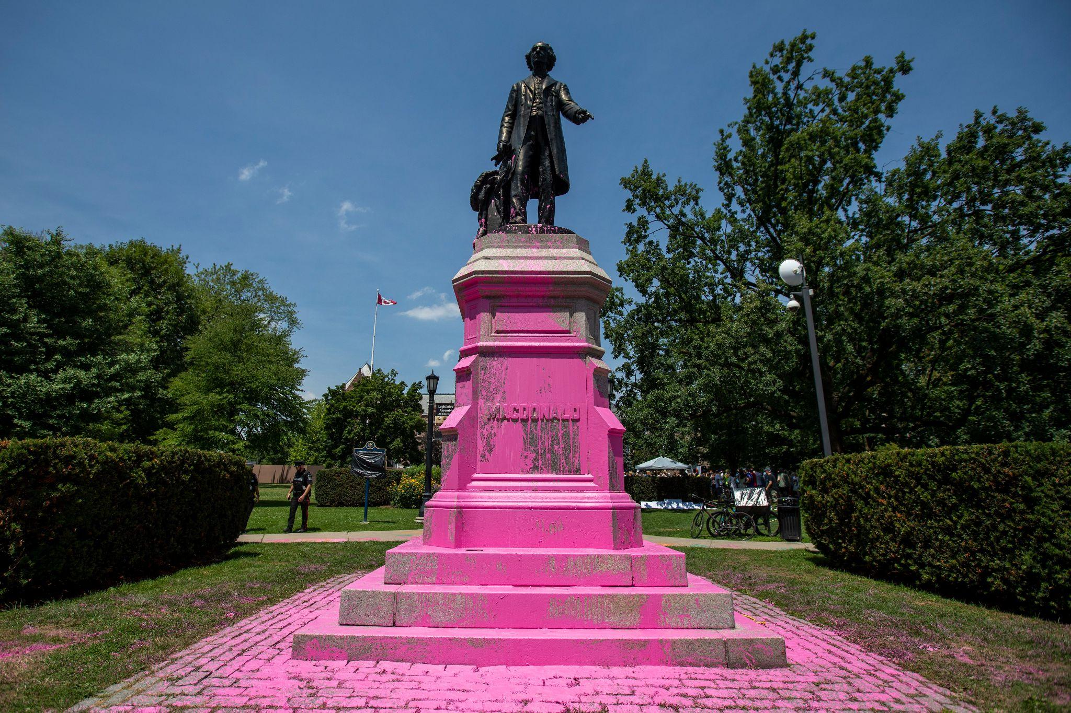

Figure 13.5: John A. McDonald ‘monument’ beautified. Credit: Syrus Marcus Ware.

Our final site was the statue in the park — an area where we could be cornered. In mid-action at this site, the police surrounded us. They stopped the activists near the van with the paint, detained and arrested three attendees at the protest. We all scattered. A BLM leader on the megaphone encouraged people to disperse and disappear quickly.

I took off down the street and was chased by cops on foot and on bicycles. I got away in ways I won’t repeat because I may need these strategies again in the future. It took three hours for the cops to drive the arrestees from Queens Park down to 52 division, six blocks away. They drove them around, handcuffed in the back of separate police cars in hot temperatures with windows closed, no air conditioning, and no access to washrooms.

The activists present at the action did a huge call out and got a couple of hundred people down to the exterior of 52 division and began a vigil until we could get our people out. We had food donations and supplies dropped off. People began making signs, covering the police station signage and the windows at the front of the station. As the day wore on and we had no knowledge of how long it would take to get our people out we called for a 6pm rally. At 6pm, we had drummers and guest speakers talk about justice and prisons and policing and the racist monuments and more. I was shaking with grief. I was full of rage watching the smug police officers watching us and our rally at their stationed posts at the door. I was scared for my comrades who were inside and in danger. I knew what I had to say — something bubbling up — a mixture of all of these emotions at once. I got on the microphone and said this:

Defund, Disarm, Dismantle, Abolish! We are winning — we have already won. That’s why they are so afraid of the defund movement. The movement to defund and abolish the police is a global movement. People are screaming it from their homes, painting it on statues and on the streets in such vibrant and bright colors that you can see it from space. They’re holding our comrades in there. These people are our beloveds. They have put their lives on the line in support of Black lives, in support of Black freedom. They have joined with activists saying ‘no more’ to statues of colonialism and white supremacy […] Our people are in there. They are holding a Mad[2] woman in there — they’re denying her access to her medications. They’re denying her access to a doctor. We know what the police do. We must have her free tonight! She will be coming home with us tonight. The police and prison system do not make our communities safer or more secure. They have never meant safety for Black people, for Indigenous people, for trans people, for disabled people, for Mad people, for migrant people, for sex workers, for HIV positive people, and for drug users. They do not mean safety for any of us. They are the violent ones! They are the violent ones! We will not leave until they are free. Free the three people being detained here! Tonight, the police are not protecting them. They are not protecting you, they are not protecting us. We say ENOUGH! We say disarm the police, we say dismantle the police, we say abolish the police! They will not take another Black person! They will not take another Mad person. We will not let them. The days are over of police picking us up and driving us around for hours in cars, and booking us and leaving us to disappear from our communities. That time is over. We will come out here every fucking time you take one of us. You will not take any more of us. We will not let you. Defund! Disarm! Dismantle! Abolish!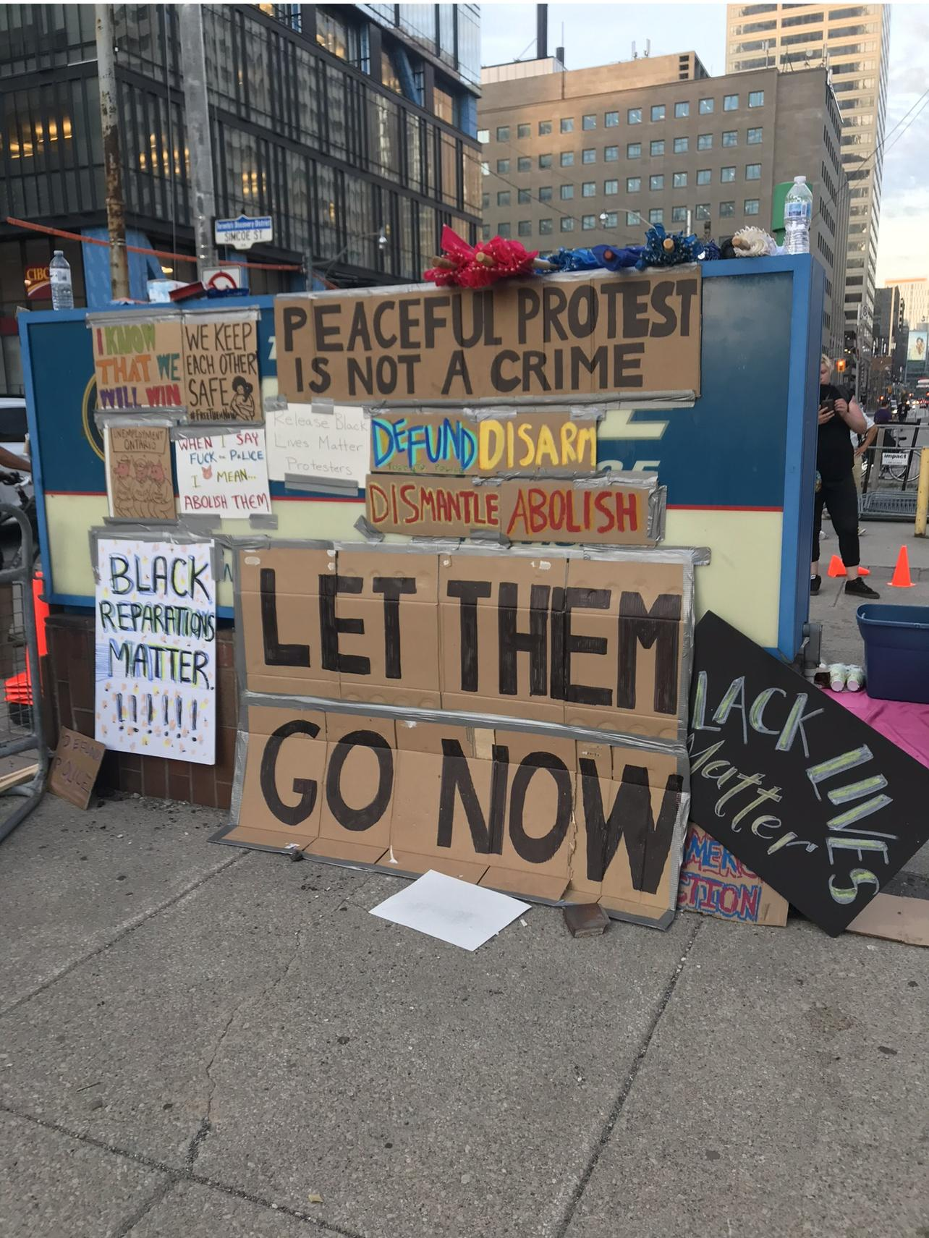

Figure 13.6: Police headquarters (52 Division) sign covered with placards and protest signs. Photo credit: Syrus Marcus Ware.

I felt relief speaking these words, and hope, more and more hope as they resonated throughout the crowd and people started clapping and chanting back, a call and response.

Others gave speeches like mine — some people sang and chanted. Local DJs came down and set up a dance party in front of the cop shop. We cheered and yelled and rallied. And while we did, they slowly and quietly moved the activists from 52 division to other police stations across the city — three different sites.

It was 3am before we got word through the legal team that they were being released and we made plans to gather them. Everyone cheered and celebrated their release. We packed up and left the police station.

Shortly after, the police started casing my block. I live on a small street with two buildings on it and there is no need for anyone to drive down the street unless you live there. However, in the days following the arrests, the police were everywhere on my tiny street. My neighbors were worried — why were there police everywhere? They held a town hall meeting for the building. Together, we crafted a no police rule for the building to provide safety for Black families and racialized and marginalized folks living in the building. Indeed, there were so many in our building who were rightly freaked out by the cops being everywhere and trying to get into our building from time to time.

It was decided that the best decision was to get me out of the city for a while, so under the cover of night I got in an Uber booked by someone else to a second location, where I switched cars and got in a second Uber, before finally arriving at my destination. I stayed in the safe house for about a week, growing more and more anxious about what was coming. I felt a profound sense of failure. We had done countless actions — taken over police headquarters for a 15-day sit-in in 2016; taken over the Special Investigations Unit in 2016, stopping all work there that day; and other demos throughout the years. We had never had arrests prior.

Together, our team went over what could have been done differently to prevent what happened in the future. The three arrestees faced charges and lived through a year of surveillance and restrictions on their movement and living before their charges were finally dropped in July 2021.

_/_/_/

It’s now the summer of 2022 and the uprising has quieted down a bit, though racial injustice continues and Black deaths at the hands of the police continue too. Most recently, a Black food delivery driver was shot 90 times by police during a traffic stop, while a week later a white person who shot up a crowd was taken into custody safely and carefully with no injury. Black lives are still being targeted by policing, this monument to slavery and colonialism, this violent enterprise designed to uphold white supremacy across the nation state.

I am ready for more actions. Based on our study of the ‘failure’ in 2020 and the resulting trauma these arrests caused in our lives and the lives of the arrestees, I feel both ready for action and unprepared for what may come. But I am holding onto hope through the words of Assata Shakur in her 1980 address to the people after her escape from prison:

Sisters and brothers, the first thing I wanna say is that I love you, and the second thing I want to say is that we can win. We will win our liberation. And in order to win our liberation we have got to think positively. We have got to believe that we can win. And if we don’t believe that we can win, we are whipped before we start. We’ve got to realize what dangers exist and we’ve got to look at those dangers realistically. We can’t afford to have a subjective distorted irrational fear. We’ve got to look at the obstacles to our liberation coolly and clearly and to develop ways to get rid of those. For us to struggle, for us to fight for our liberation, and for our nation.[3]

We have to believe that winning is possible, and reflecting on the arrests and the action I wonder if perhaps this is how we avoid future failures — actions gone wrong, people’s lives affected — by believing we can do that which has not been done before, and by learning from our mistakes as we go.

We have to believe that it is possible to upset this violent and wicked system. How do we get to abolition? To thriving in an abolitionist community? We get there by believing it’s possible to have safety, security, and solutions to conflict, crisis, and harm without carceral violence and punishment. This action was a spark, something that ignited discussion and led to significant changes. Perhaps the action was not a complete failure in that several statues have been removed officially and unofficially since our actions that day. The statue of John A. McDonald in Montréal was pulled down in a protest in 2020. Satisfyingly, the statue's head popped off when it hit the ground. Similarly, the statue of Egerton Ryerson that was splashed was pulled down in an Indigenous Resurgence protest about residential schools. These protests marked the discovery of the remains of 215 children on the grounds of residential ‘schools’ in Northern Turtle Island (this count is now at over 10,000 remains found). The statue’s head was severed with a skill saw and put on a spike at 1492 Land Back Lane — a site of Indigenous resistance in the province of Ontario. The university named after Egerton Ryerson officially changed its name in 2022 to Toronto Metropolitan University to address the white supremacy and violence of its namesake and to distance the university from this figure in history. Why did it take arrests and brutality towards our people to push people to see we needed a change? I’ve spent the last two and half years reflecting on what went wrong that day and what could have gone even worse had conditions been different.

Change is starting to happen. The arrests drew attention to these statues and ultimately created an essential dialogue in our community. The police violence that day with the arrestees proved our point further about their racism, violence, and ableism. More and more people got turned on to the problems of policing, the violence of the system, and the attack on the right to peaceful protest. Still, this experience rings alarm bells about the right to protest being dismantled and under attack and the criminalization of dissent is on the rise. This is happening all while previously gained rights and justice successes are at risk or taken away. We have more and more to protest, and less and less of a right to do so. Change needs to be won, and from this reflection from the front lines I’m offering that we have a lot to learn about losses, as we strive for Assata Shakur’s ‘winning’ and for Black justice. We are still on the front lines, pushing for change and for justice and moving steadily towards a Black affirming Afro Future — a speculative imagining made real through our change-making actions today.

## Conclusion

We started with artists, and we end with artists.

Figure 13.7: Screen capture of Ravyn Wngz talking on CP24. Photo credit: Syrus Marcus Ware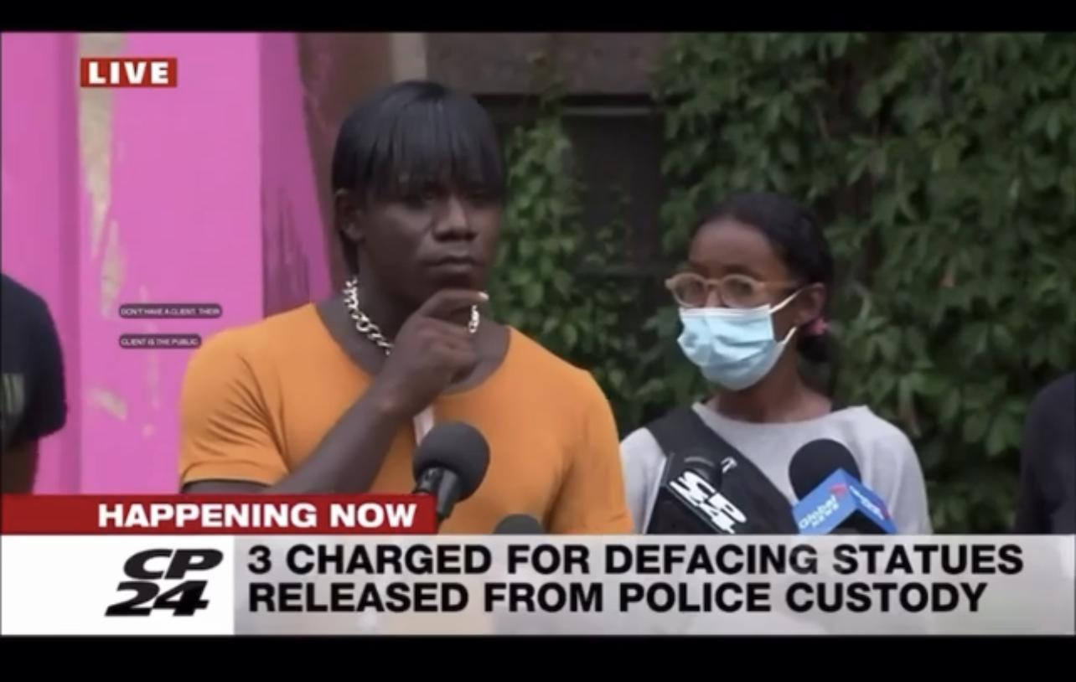.

Much happened in the days and weeks following the arrests, and even more in the years following. Artists, many of whom joined us in painting the street on Juneteenth, wrote an open letter calling for charges to be dropped and garnered almost 3000 signatures in two weeks. People who heard activist Ravyn Wngz’s speech at the press conference following the arrests were moved and politicized. Her speech was shared almost a million times. Will this influence more people to consider the monuments to slavery and colonialism and to consider abolition? Time will tell.

We continue to scream from every rooftop ‘Defund, Disarm, Dismantle, Abolish!’ until we are all free. Until we have all won, as Assata encouraged. Until we all have self-determination. And until all of the monuments to slavery and colonialism have been torn down.

## Bibliography

Assata Shakur. ‘Clips from her 1980 Address to the People after Her Escape from Prison.’ *The Freedom Archives*, <https://search.freedomarchives.org/search.php?view_collection=132&format=mp3#.>

1. Juneteenth is a moment commemorating the signing of the emancipation proclamation, or theatre the last state to adopt it formally adopting this proclamation. It also commemorates some significant Black uprisings that happened in June.
2. In Canada and across North America/Turtle Island, ‘Mad’ is a term that being reclaimed and is a political and empowering term for folks labelled with psychiatric diagnosis’s and who have been in the psychiatric system.
3. Assata Shakur. "Clips from her 1980 Address to the People after Her Escape from Prison." *The Freedom Archives*, <https://search.freedomarchives.org/search.php?view_collection=132&format=mp3#.>